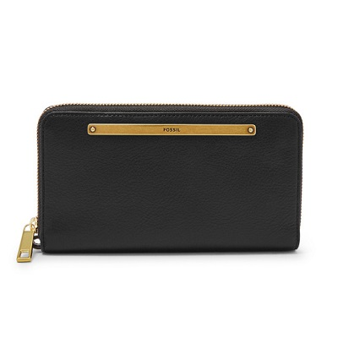

Liza Zip Around Clutch

PRODUCT DETAILS

**Silhouette: Zip Around Clutch**

**Exterior Material: Leather/Polyurethane Trim**

**Interior Details: 1 ID Window, 1 Zipper Pocket, 2 Bill Compartments, 2 Gusseted Pockets, 13 Credit Card Slots**

**Measurements: 7.69"L x 1"W x 4.5"H**

**Warranty: 1 Year Limited**